Quiz 1:

Quiz 2:

Figure 1 shows a 4 to 1 mux connected to a D register. Make a table with each possible value for S1 and S0, and explain what this design does. Someone on the internet claims that this is the same thing as a JK flip-flop. Is this right or wrong, and why?

Figure 2 shows a logic diagram similar to what we saw in chapter 2. Make a table indicating what it does for all possible values of A0, A1, A2, and A3.

Quiz 3:

1. For figure 1, what are the possible values of the Mux outputs? Describe what these do in terms of the S1, S0 values. What are the possible microoperations that this can perform?
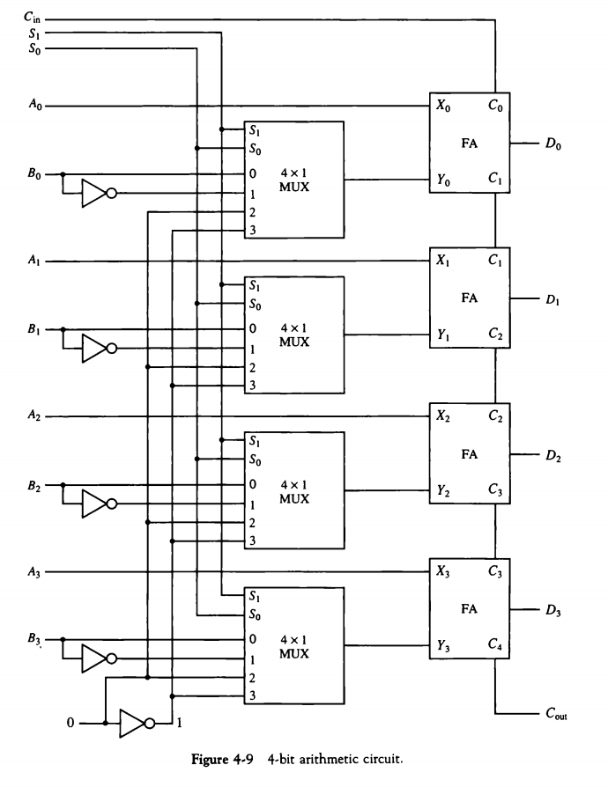

Quiz 4:

2. For each of the following binary values, shift to the right in three ways that we discussed: 1110100 and 01110100. What is the purpose of the arithmetic shift right?

Quiz 4:

1. Memory contents (in hexadecimal) are 005, 001, 0123 for addresses 000 to 002, then 2002, 1000, 7800, F400 for addresses 80A through 80D. AC starts with values 0F24, PC has the value 80A, and AR has the value 4F5. Starting with timestep T0, describe what happens until the next T0. Make sure to indicate any updated register values as they happen.

2. Translate the following program to machine language:

CLC
STA C
ADD B
ISZ B
HLT
A, DEC 4
B, HEX 0
C, HEX FFFD

